Kitten Heels: Press Tracker

Pre-Launch

Maureen has been interviewed by:
- Fraser Clarke at the Lennox Herald
  - Wed 04/09/24
- Fiona Holland for the Dumbarton and Vale of Leven Community Advertiser
  - Wed 04/09/24
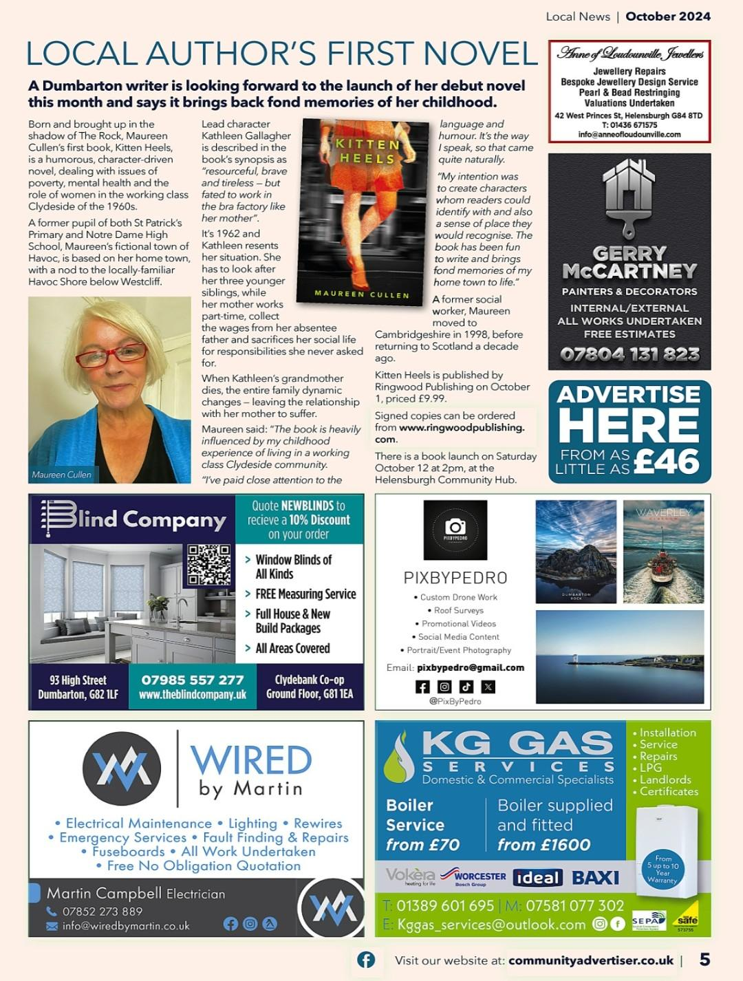
- Emily Moore at the Dumbarton and Vale of Leven Reporter/Clydebank Post
  - Thurs 12/09/243
  - Dumbarton author explores 1960s Clydeside with new book
- Helensburgh Advertiser (Tristan Thompson)
  - New novel by Maureen Cullen explores life in 1960s Clydeside
- Helensburgh Community Advertiser
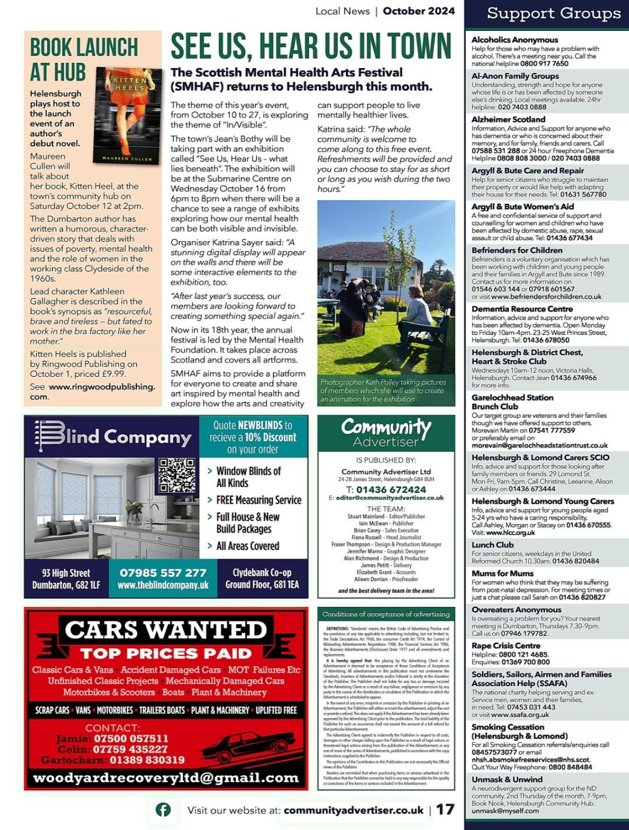

Reviews!
- The Herald Scotland, Was Clydeside in the 1960s really this grim?, Alastair Mabbott
  - “An accomplished first novel imbued with all the immediacy of a memoir”
  - “It’s possible to pull readers in with no more than the promise of a fix of nostalgia [...] but Kitten Heels has much more to offer than that.”

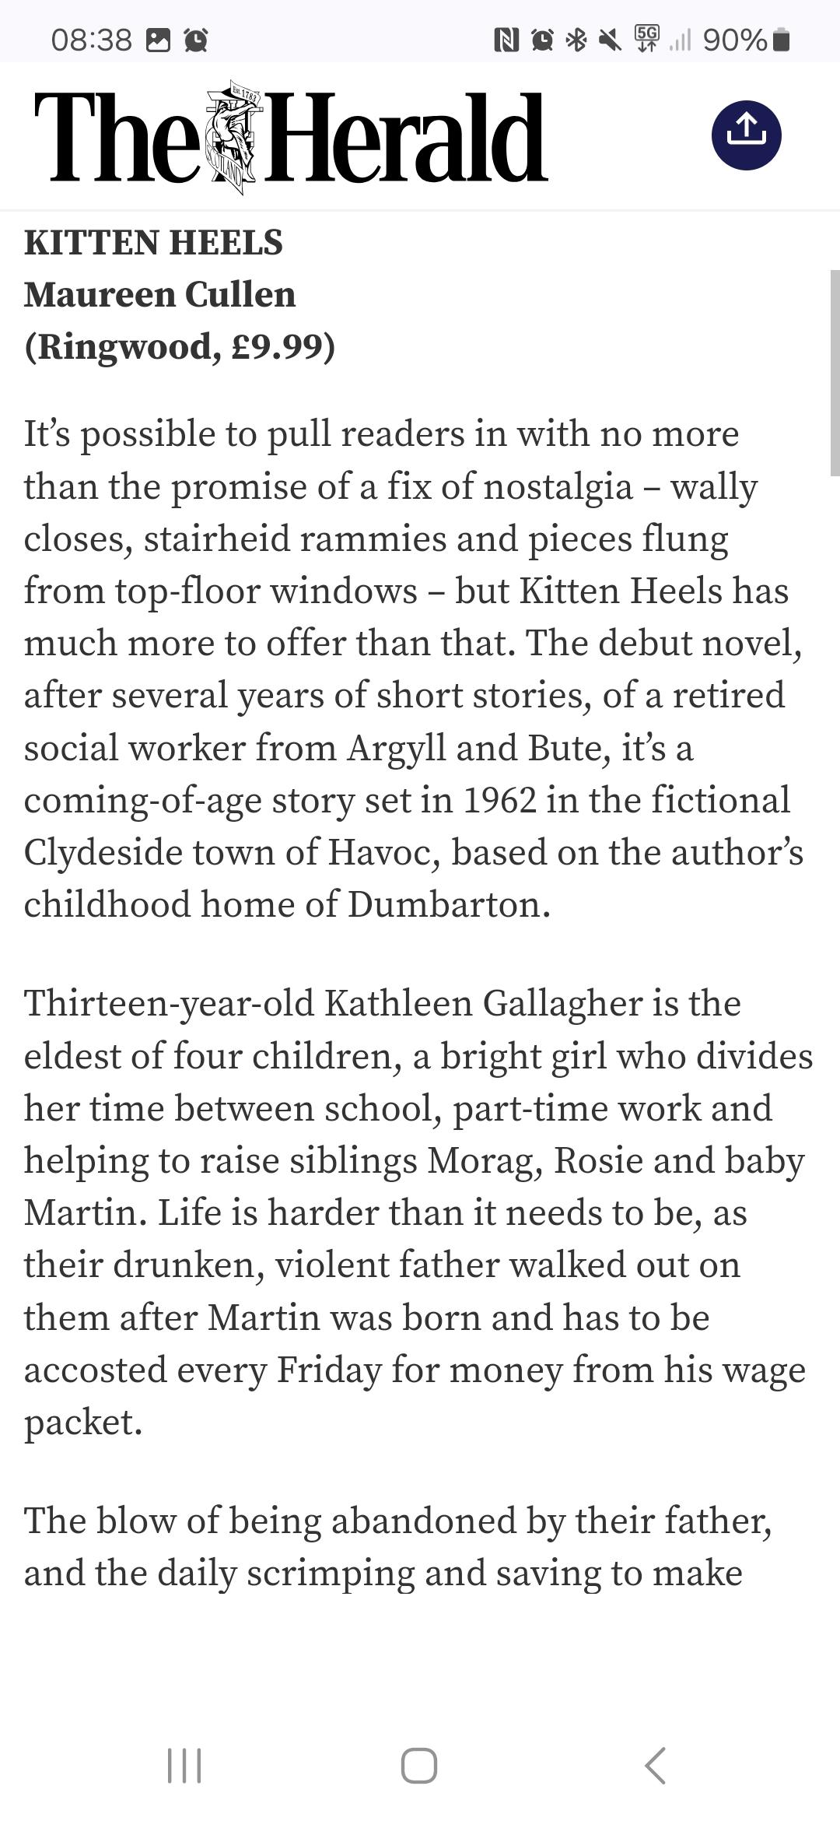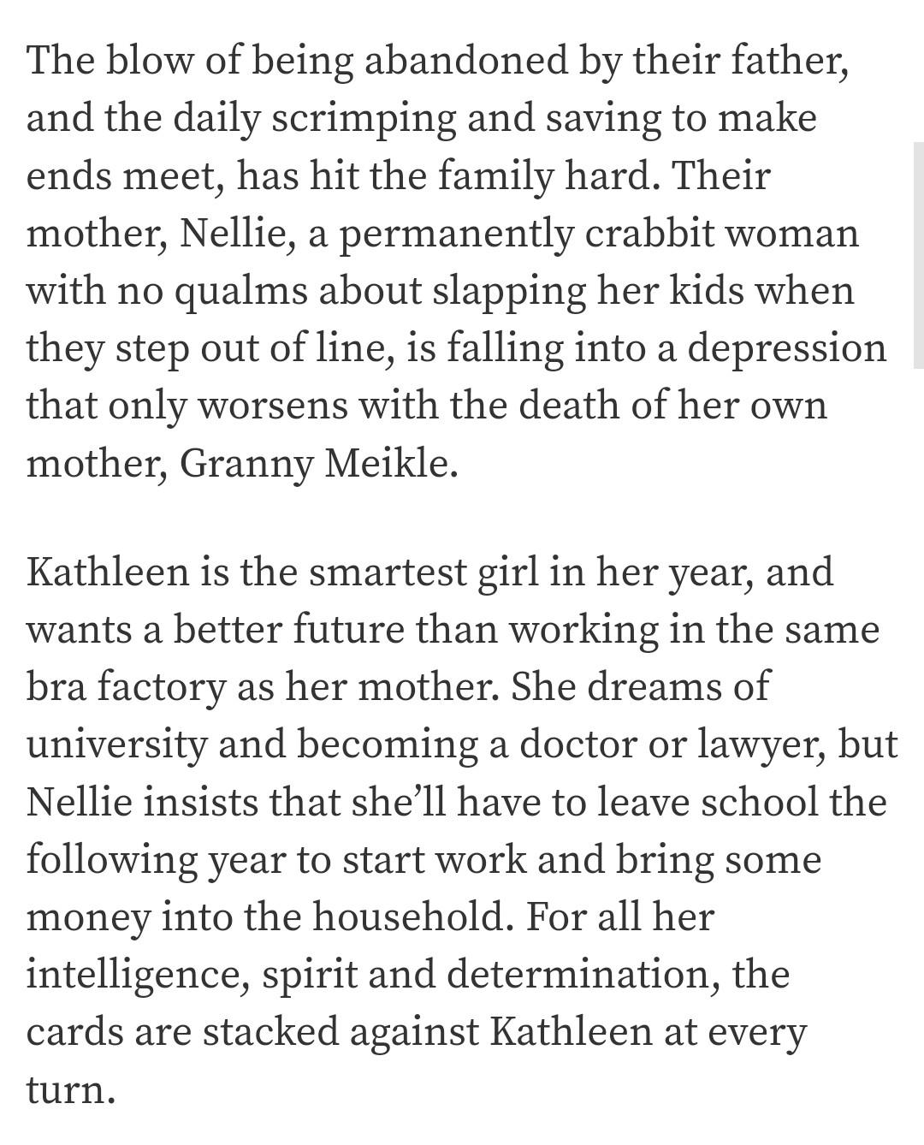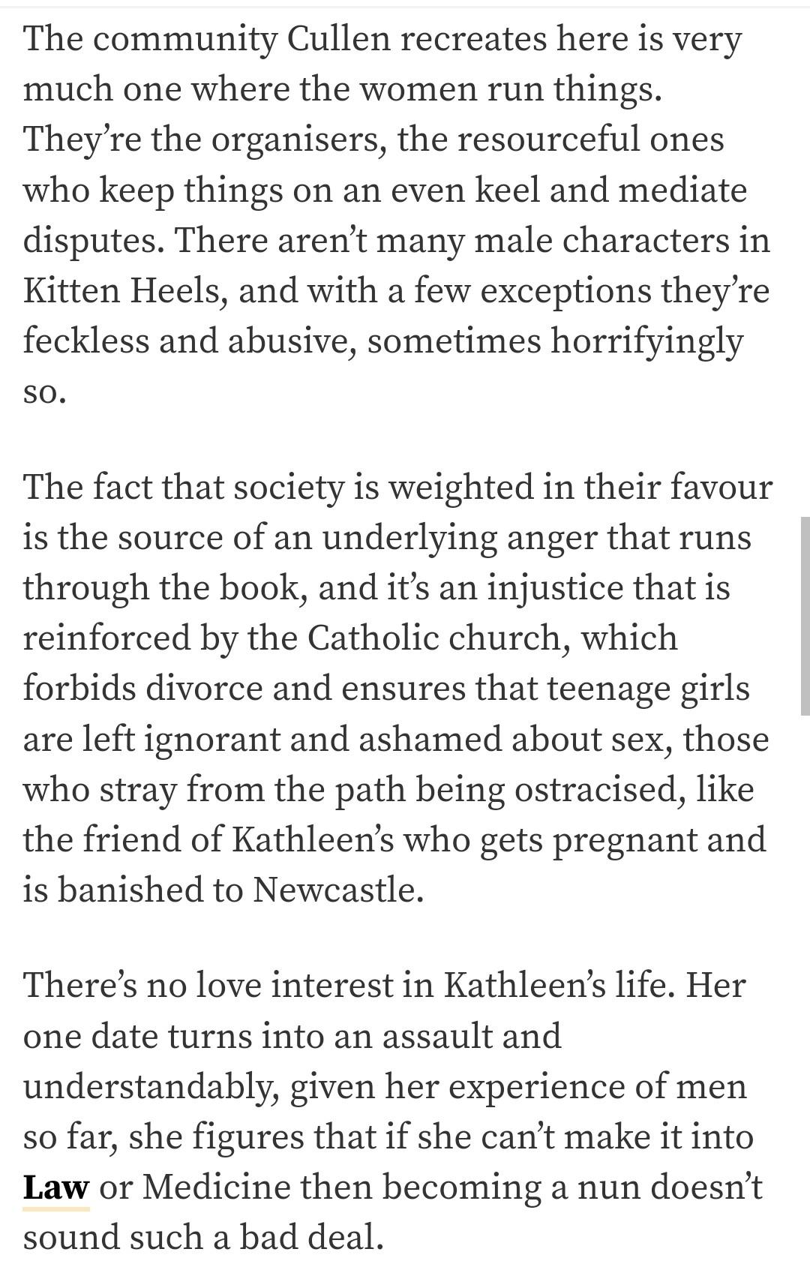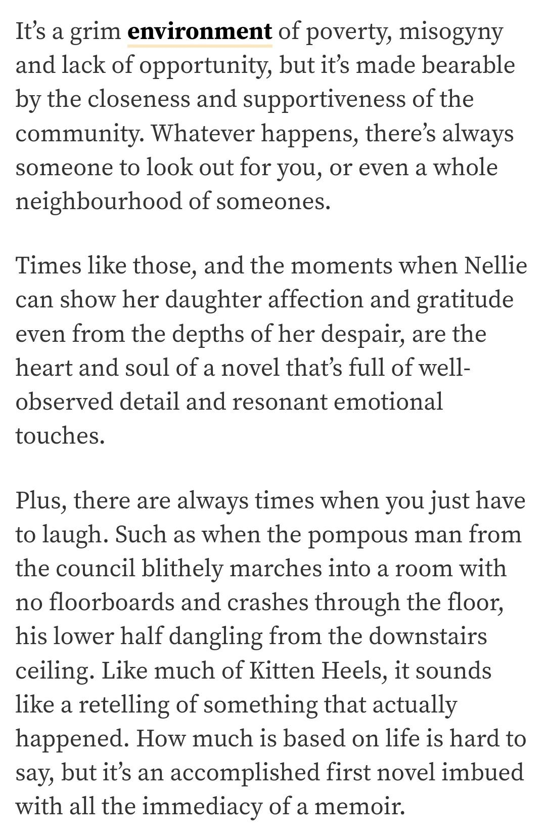
- Rob McInroy:
  - “I’ll finish reading this tonight and that’s a pity because I’ve enjoyed inhabiting Kathleen’s world. Beautifully written. Honest but warm, with a delightful central character.”
- Maggie MacKay:
  - “Maureen Cullen’s debut novel is a lively, deftly crafted story of a West of Scotland’s family life in the nineteen sixties. Through the voice of fourteen-year-old Kathleen, laden with responsibility for her younger siblings, the reader follows their hectic ups and downs in a tenement community. As this daughter grapples with adolescence, her Catholic mother sustains a compelling presence, powering her oldest child’s behaviour. Cullen creates a pervasive tension between the two. The dialogue is dynamic and energising. The characters are well drawn and believable. Her writing is authentic and balanced with comic episodes, mishaps and emotional drama. And a satisfying ending.”
- Paul McVeigh (author of The Good Son):
  - “Funny, frank and moving. We need more books like this."

Reader reviews:
- “An incredible read with a wonderful flow, easily the best book I've read this year!!!”
- “I thoroughly enjoyed reading Kitten Heels. The novel is a remarkable achievement, beautifully written, with strong memorable characters and a great plot. It’s funny, sad, smart and tender and I’d love to read more about Kathleen and her struggles to find her way in a world where the odds are stacked against her and her family.”
- “Kitten Heels had me hooked from the beginning. An authentic, engaging book with good characterisation, believable dialogue and sensitive use of humour. It made me laugh and care. Highly recommended.”
- “Well drawn characters, plenty of humour, and lovely characterisation: a joy to read.”
- “This book made me laugh out loud and also made me cry!!! The characters are so very real. It took me all the way back to growing into my own kitten heels – brilliant!!”
- “Super story reflecting the life at that period. Written with humour and sensitivity”
- “Kitten Heels is a beautifully paced novel with engaging characters: the writing is clear and the dialect added much by way of characterisation, and I was able to identify and empathise with Kathleen especially, although even the minor characters were sharply observed and clearly drawn. A delightful read.”
- “Kitten Heels is a beautifully paced novel with engaging characters: the writing is clear and the dialect added much by way of characterisation, and I was able to identify and empathise with Kathleen especially, although even the minor characters were sharply observed and clearly drawn. A delightful read.”
- “I loved this book. It’s a real page turner. Loved following Kathleen and I loved the Scottish dialect.”
- “A beautifully drawn central character and a vivid evocation of 1960s Glasgow.”

Elaine Sinclair, owner of Daydreams Bookshop in Milngavie and founder of The Bonnie Wee Book Club
- “What a gem of a book! [...] It flows really well and is full of Glaswegian charm, whilst revealing the problems facing working class families in the 1960s. I’d imagine it will be very nostalgic for those who grew up in the west of Scotland at that time.”

